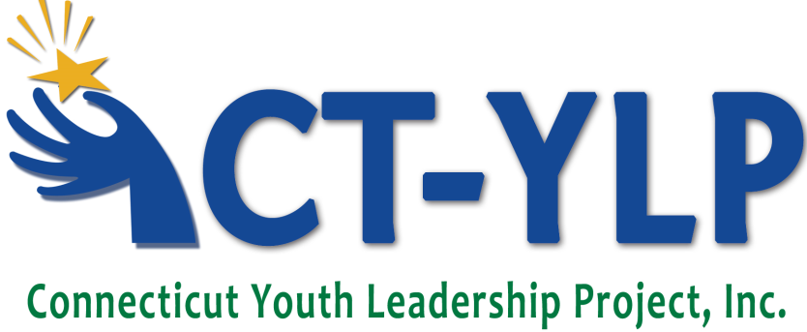
The Connecticut Youth Leadership Project is an organization that provides opportunities for youth with disabilities to realize their leadership potential, develop strong self-advocacy skills and to have a positive influence in their community. It costs approximately $2,300 for each delegate to attend the forum and participate in follow-up activities. There is no cost to the delegate to attend.
The Connecticut Youth Leadership Project is a 501(c)3 non-profit organization. We rely on grants and private funding to run the Youth Leadership Forum for 40 delegates each year, plus engage in follow-up activities that further the mission of the organization. The generosity of our donors is vital as we continue our efforts to develop the leaders of tomorrow from the youth of today.
The organization is extremely careful with the funds entrusted to it. All of our Board members and most of our staff are unpaid volunteers who donate their time and money to this worthy cause. We have a yearly audit on our financial statements. We are also registered with the State of Connecticut as a “Charitable Entity Allowed to Solicit Funding.” More than 83% of our funds go directly to the delegates in the form of the forum or follow-up activities.

Make a Difference – Donate Today!
The act of making a donation to the Connecticut Youth Leadership Project will help assure that high school students with disabilities are given opportunities to increase their leadership potential. As a 501(c)3 organization, a donation to the Connecticut Youth Leadership Project is tax-deductible within the fullest extent of the law.
Please accept my contribution to the Connecticut Youth Leadership Project
Name:
Address:
City:
State:
Zip:
Phone Number:
Email:
Increase your donation through matching funds. Many employers will match your personal donation. Check with your company for more information on matching gift programs.
Mail this form and your donation to:
The Connecticut Youth Leadership Project
c/o John Gentile, President
23 Rose Lane
Danbury, CT 06811

